**DAY 02**

Question: Difference between Document and Windows Object.

Solution:

Window is the first thing that gets loaded into the browser. This window object has the majority of the properties like length, innerWidth, innerHeight, name, if it has been closed, its parents, and more.

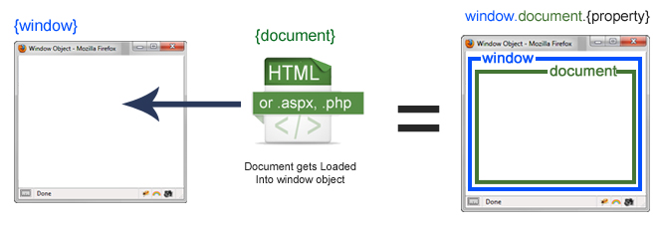

The document object is your html, aspx, php, or other document that will be loaded into the browser. The document actually gets loaded inside the window object and has properties available to it like title, URL, cookie, etc.

To access a property for the window it is window.property, if it is document it is window.document.property which is also available in short as document.property.

The window object represents an open window in a browser.The window object represents a window in the browser. An object of the window is created automatically by the browser.

Window is the object of the browser, it is not the object of javascript. The javascript objects are string, array, date etc.

If a document contains frames (<iframe> tags), the browser creates one window object for the HTML document, and one additional window object for each frame.

**Window Object Properties:**

**Closed** - It holds a Boolean value that represents whether the window is closed or not.

**Console** - It returns a reference to the console object which provides access to the browser’s debugging console.

**Document** - It returns a reference to the document object of that window.

**Frames[]** - It represents an array that contains all the frames of a given window.

**History** - It provides information of the URLs visited in the current window.

**Length** - It represents the number of frames in the current window.

**fullScreen** - This property indicates whether the window is displayed in full screen or not.

**Location** - It contains the URL of the current window.

**innerHeigh**t - It is used to get the height of the content area of the browser window.

Etc.

*The important methods of window object are as follows:*

**alert()**  displays the alert box containing message with ok button.

**confirm()** displays the confirm dialog box containing message with ok and cancel

button.

**prompt()** displays a dialog box to get input from the user.

**open()** opens the new window.

**close()** closes the current window.

***The Document Object***

When an HTML document is loaded into a web browser, it becomes a document object.

The document object is the root node of the HTML document.

The document object is a property of the window object.

The document object is accessed with:

window.document or just document

***Document Object Properties and Methods***

The following properties and methods can be used on HTML documents:

Property / Method Description

**activeElement** Returns the currently focused element in the document

**addEventListener()** Attaches an event handler to the document

**adoptNode(**) Adopts a node from another document

**anchors** Deprecated

**applets** Deprecated

baseURI Returns the absolute base URI of a document

body Sets or returns the document's body (the <body> element)

charset Deprecated

characterSet Returns the character encoding for the document

close() Closes the output stream previously opened with document.open()

cookie Returns all name/value pairs of cookies in the document

createAttribute() Creates an attribute node

createComment() Creates a Comment node with the specified text

createDocumentFragment() Creates an empty DocumentFragment node

createElement() Creates an Element node

createEvent() Creates a new event

createTextNode() Creates a Text node

defaultView Returns the window object associated with a document, or null if none is available.

designMode Controls whether the entire document should be editable or not.

doctype Returns the Document Type Declaration associated with the document

documentElement Returns the Document Element of the document (the <html> element)

documentMode Deprecated

documentURI Sets or returns the location of the document

domain Returns the domain name of the server that loaded the document

domConfig Deprecated

embeds Returns a collection of all <embed> elements the document

execCommand() Deprecated

forms Returns a collection of all <form> elements in the document

getElementById() Returns the element that has the ID attribute with the specified value

getElementsByClassName() Returns an HTMLCollection containing all elements with the specified class name

getElementsByName() Returns an live NodeList containing all elements with the specified name

getElementsByTagName() Returns an HTMLCollection containing all elements with the specified tag name

hasFocus() Returns a Boolean value indicating whether the document has focus

head Returns the <head> element of the document

images Returns a collection of all <img> elements in the document

implementation Returns the DOMImplementation object that handles this document

importNode() Imports a node from another document

inputEncoding Deprecated

lastModified Returns the date and time the document was last modified

links Returns a collection of all <a> and <area> elements in the document that have a href attribute

normalize() Removes empty Text nodes, and joins adjacent nodes

normalizeDocument() Deprecated

open() Opens an HTML output stream to collect output from document.write()

querySelector() Returns the first element that matches a specified CSS selector(s) in the document

querySelectorAll() Returns a static NodeList containing all elements that matches a specified CSS selector(s) in the document

readyState Returns the (loading) status of the document

referrer Returns the URL of the document that loaded the current document

removeEventListener() Removes an event handler from the document (that has been attached with the addEventListener() method)

renameNode() Deprecated

scripts Returns a collection of <script> elements in the document

strictErrorChecking Deprecated

title Sets or returns the title of the document

URL Returns the full URL of the HTML document

write() Writes HTML expressions or JavaScript code to a document

writeln() Same as write(), but adds a newline character after each statement